BECAA PROFESSIONAL EVENT  Objective – Share experience and help others grow professionally  Agenda:  - Registration  - Objective & Goal of the Event  - Individual Speaker Series  - Round Table Discussion  - Open Forum |  | DATe & Venue  February 01st, 2020 3:00-5:00PM  Deewan Banquet, Tequila N Tacos  Address -560 Stelton Rd, Piscataway, NJ 08854; Ph-(732) 968-7000  contact us  Soumalya Chowdhury -- 201 658 8734  Joydeep Samanta – 201 565 6332  Soumyabrata Roy – 201-736-9420  Suman Chandra – 636 357 6032 |  | - THEME of the EVENT  process Automation  Speakers:  - Arindam Mukhopadhyay  - Mini Suri  - Prabir Ghosh  - Jayanta De  - Santanu Sengupta  - Amitava Chell  - Debashis Kundu  - Moloy Nath  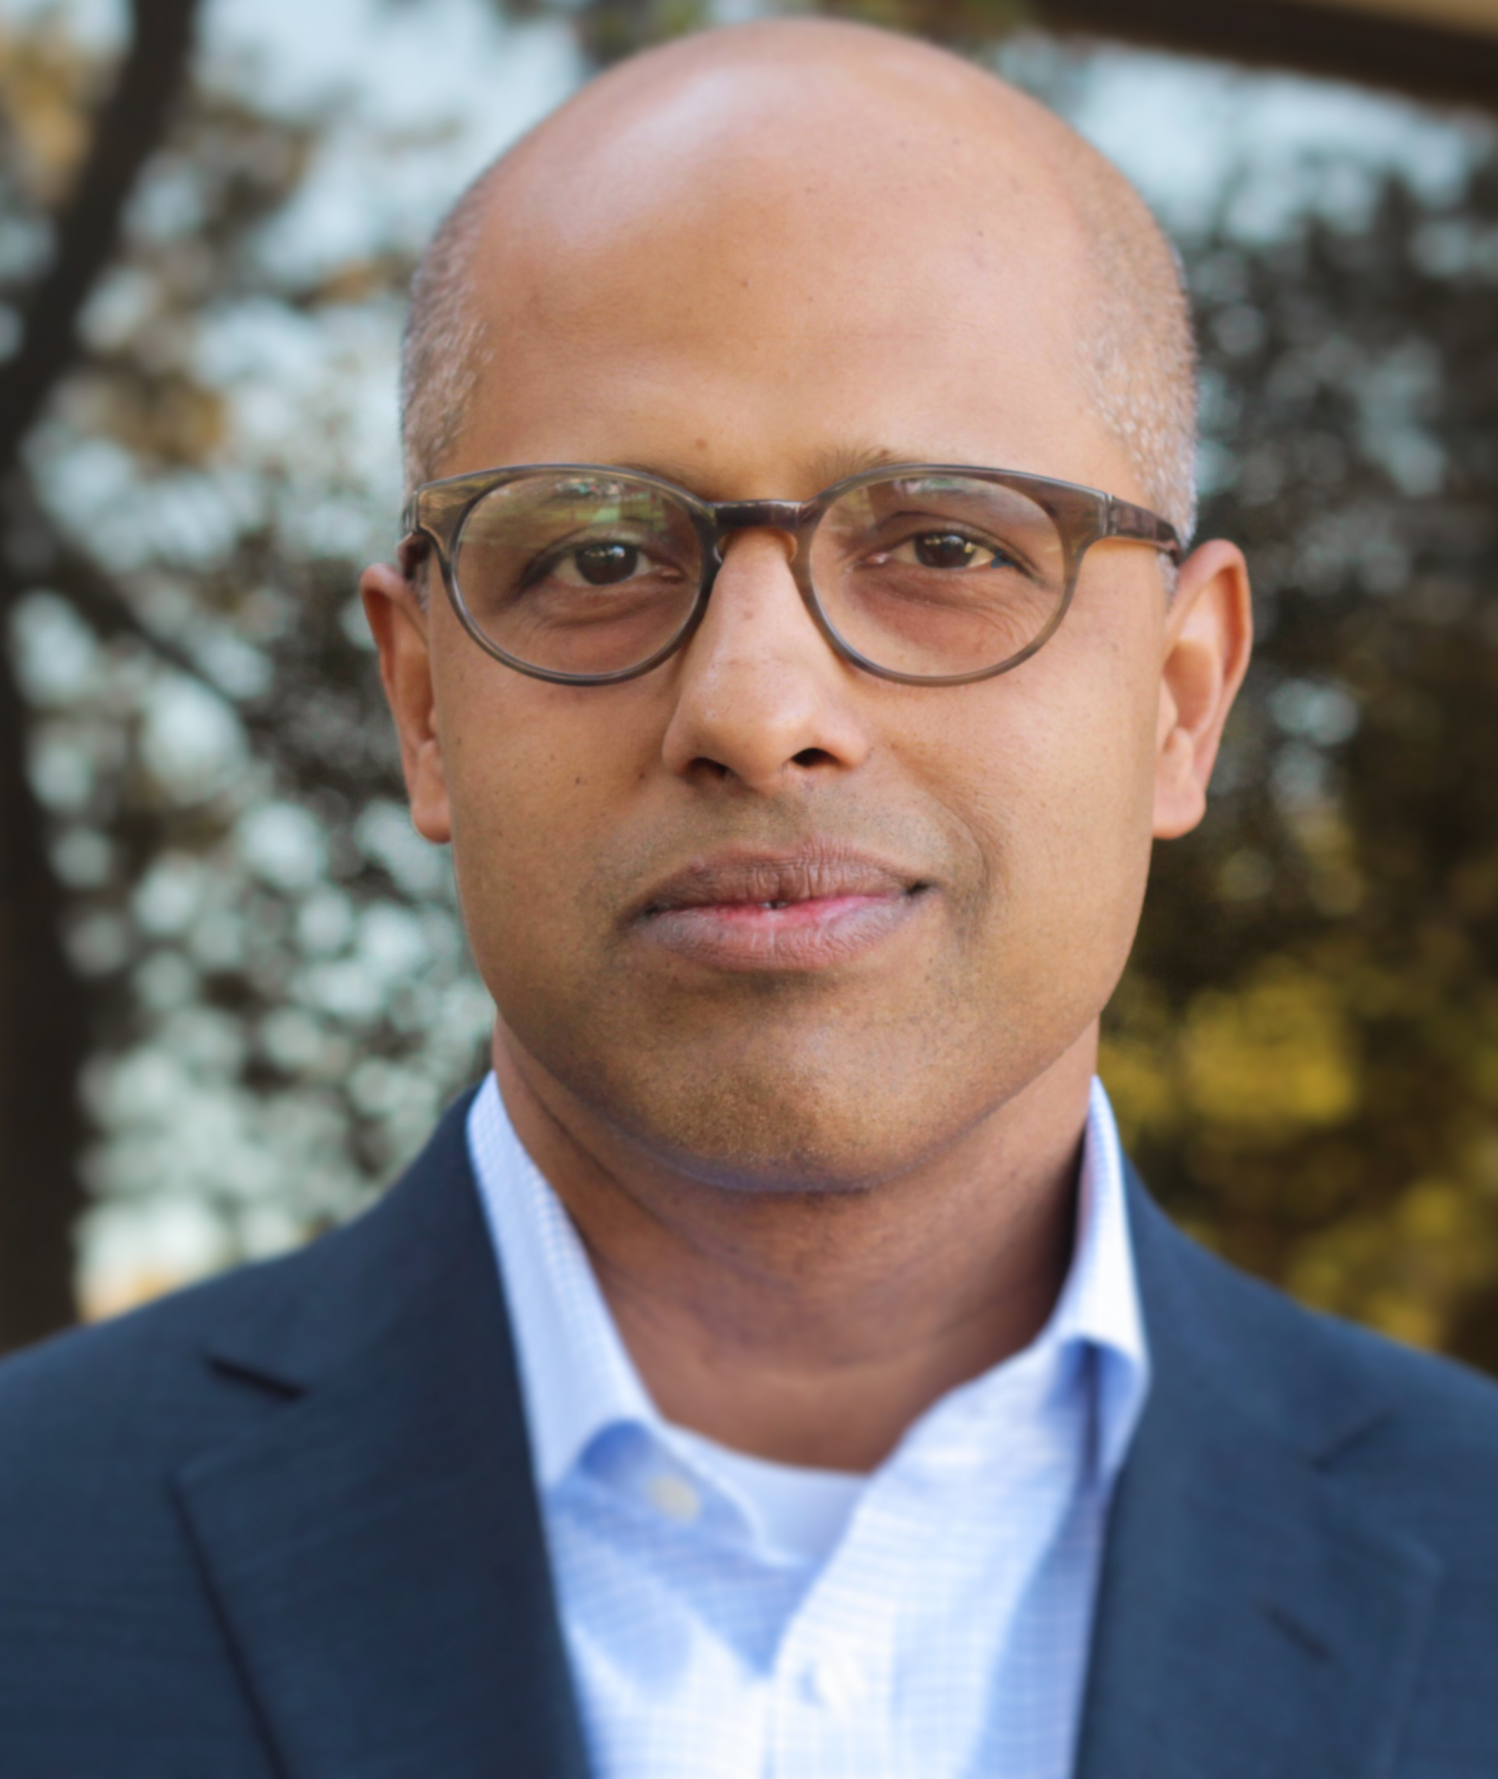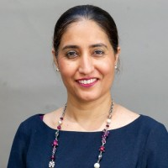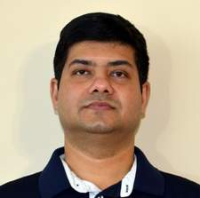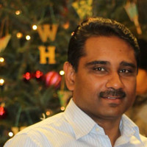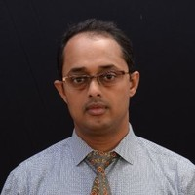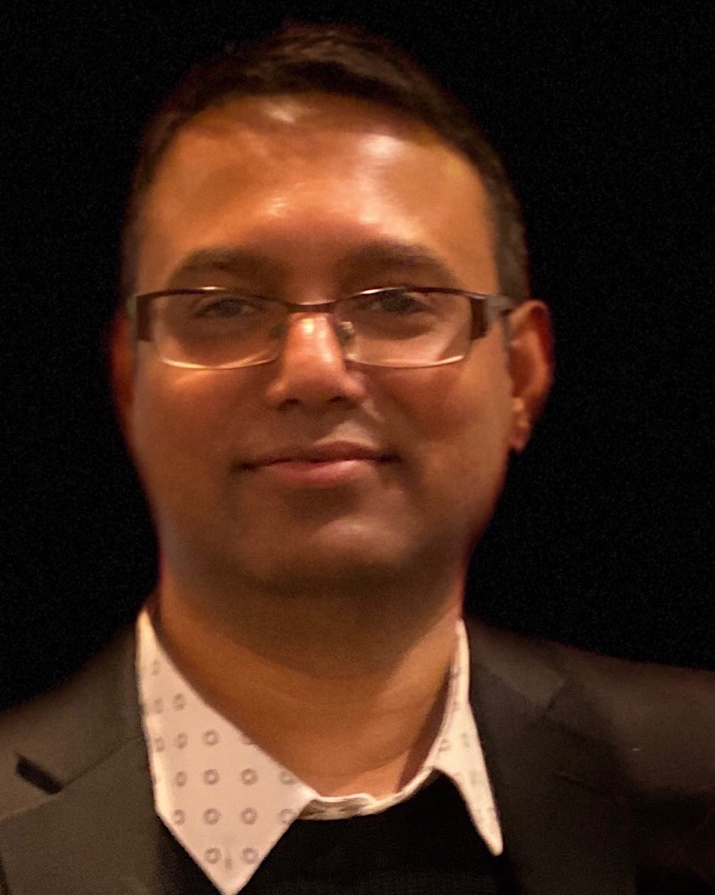  Everybody can participate in Q&A and share experiences

